**VNet-to-VNet VPN gateway**

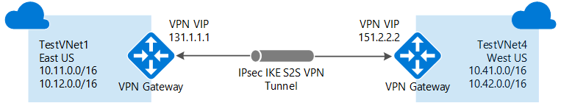

### Example settings

**Values for VNet1:**

* **Virtual network settings**
  + **Name**: VNet1
  + **Address space**: 10.1.0.0/16
  + **Subscription**: Select the subscription you want to use.
  + **Resource group**: TestRG1
  + **Location**: East US
  + **Subnet**
    - **Name**: FrontEnd
    - **Address range**: 10.1.0.0/24
  + **Gateway subnet**:
    - **Name**: GatewaySubnet is autofilled
    - **Address range**: 10.1.255.0/27

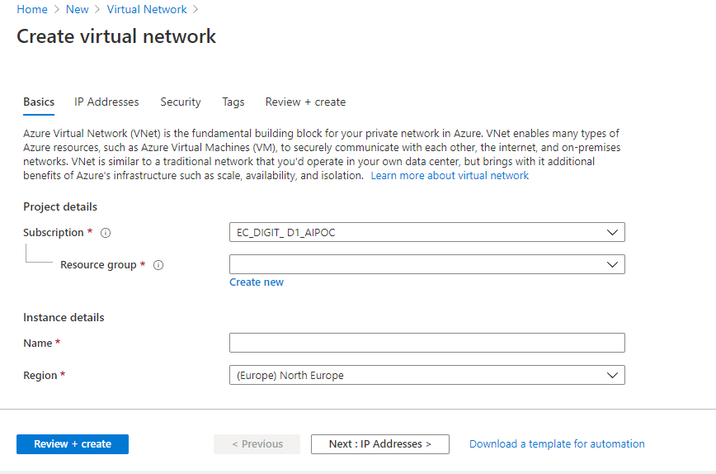

Create vnet1 with default settings

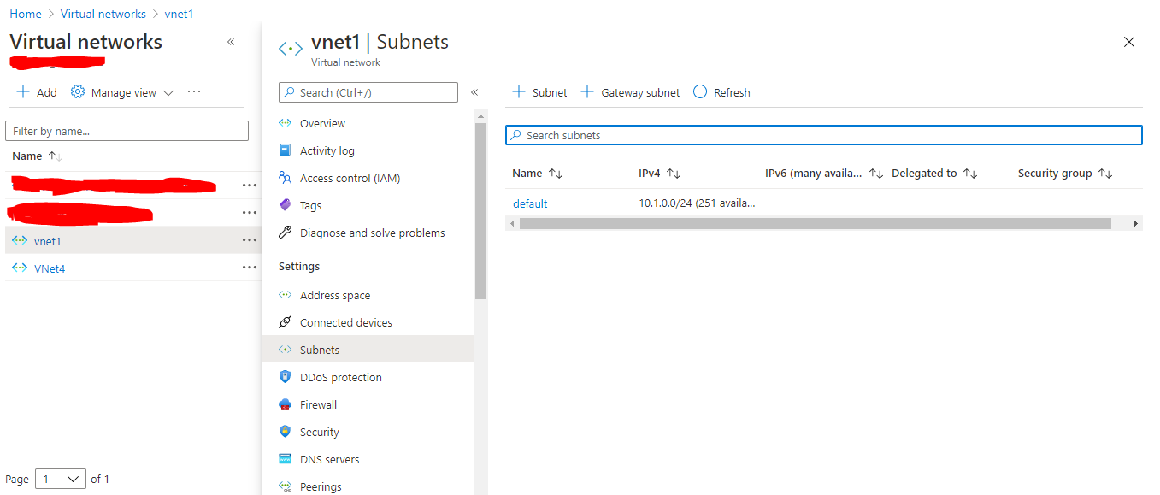

Create gateway subnet also and explain to student what is mean by gateway subnet.

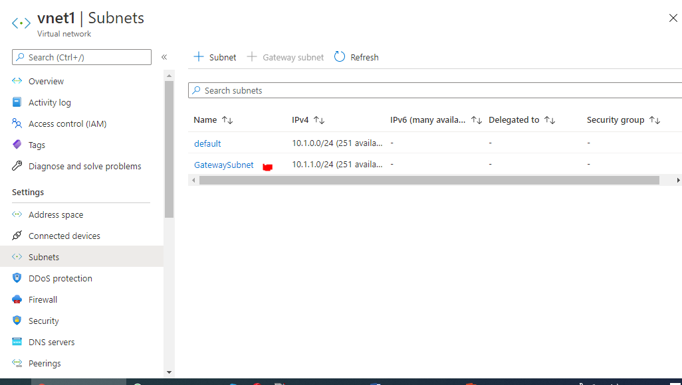

* **Virtual network gateway settings**
  + **Name**: VNet1GW
  + **Gateway type**: Select **VPN**.
  + **VPN type**: Select **Route-based**.
  + **SKU**: Select the gateway SKU you want to use.
  + **Public IP address name**: VNet1GWpip
  + **Connection**
    - **Name**: VNet1toVNet4
    - **Shared key**: You can create the shared key yourself. When you create the connection between the VNets, the values must match. For this exercise, use abc123.

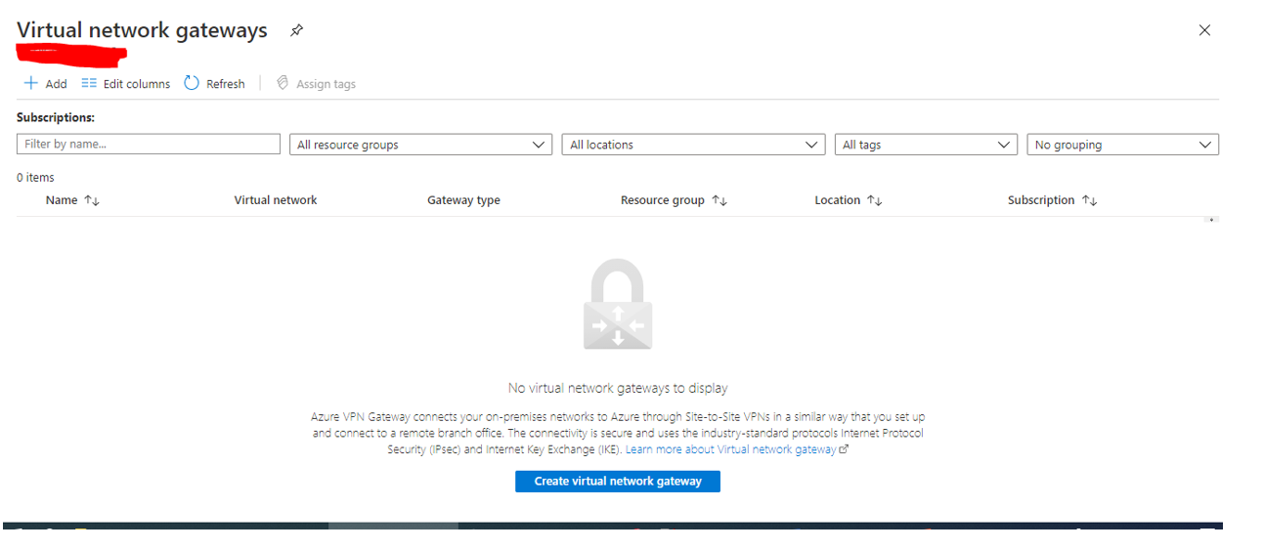

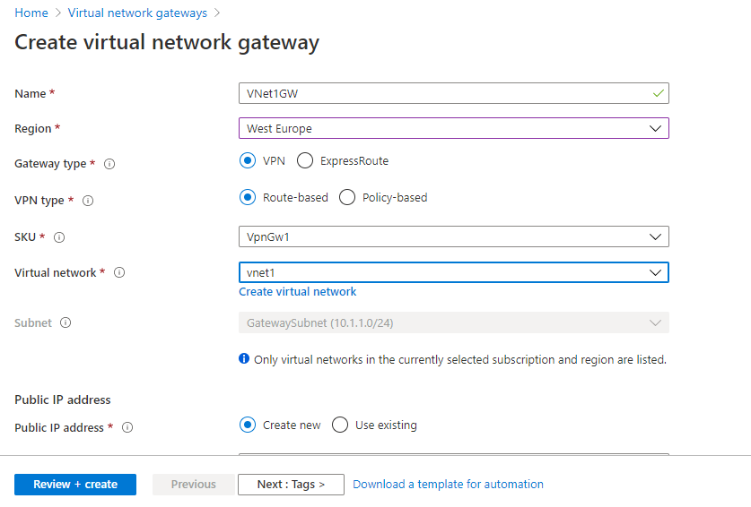

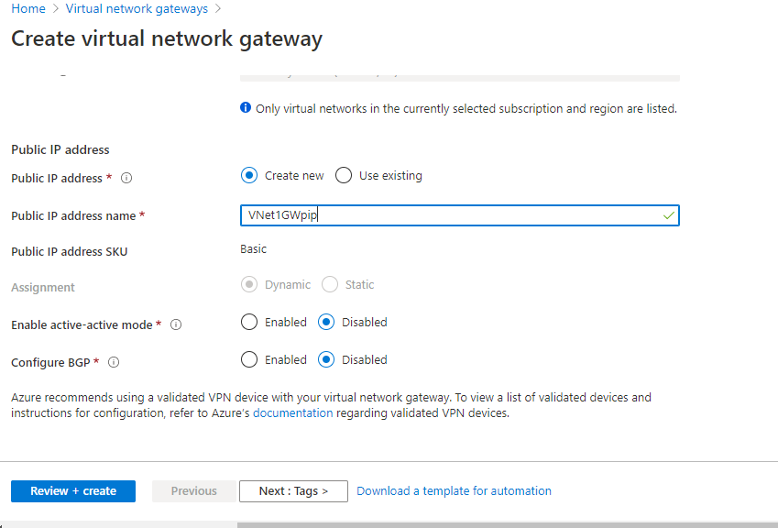

Create VNET Gateway 1

**Values for VNet4:**

* **Virtual network settings**
  + **Name**: VNet4
  + **Address space**: 10.41.0.0/16
  + **Subscription**: Select the subscription you want to use.
  + **Resource group**: TestRG4
  + **Location**: West US
  + **Subnet**
    - **Name**: FrontEnd
    - **Address range**: 10.41.0.0/24
  + **GatewaySubnet**
    - **Name**: GatewaySubnet is autofilled
    - **Address range**: 10.41.255.0/27

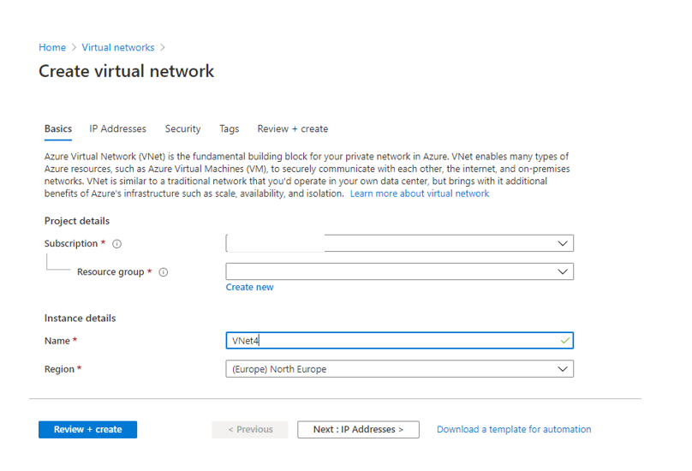

Create vnet4 with default settings.

Now create gateway subnet

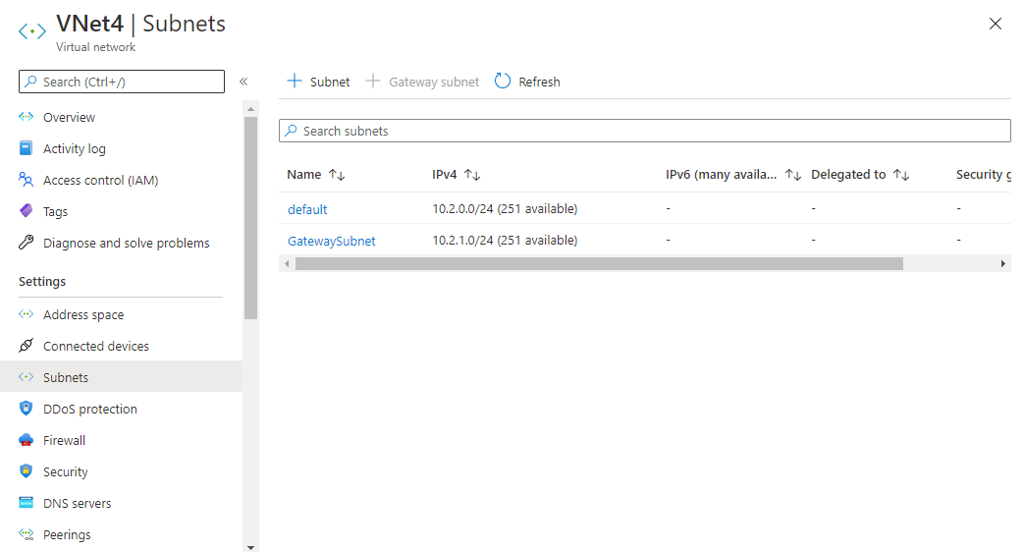

* **Virtual network gateway settings**
  + **Name**: VNet4GW
  + **Gateway type**: Select **VPN**.
  + **VPN type**: Select **Route-based**.
  + **SKU**: Select the gateway SKU you want to use.
  + **Public IP address name**: VNet4GWpip
  + **Connection**
    - **Name**: VNet4toVNet1
    - **Shared key**: You can create the shared key yourself. When you create the connection between the VNets, the values must match. For this exercise, use abc123.

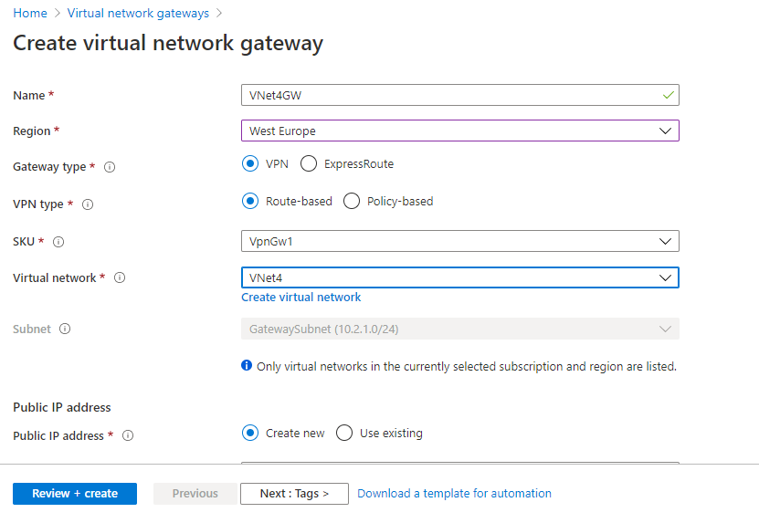

Now virtual network Vnet1 , Virtual Network Gateway 1 has been created.

Now virtual network Vnet4 , Virtual Network Gateway 4 has been created.

This will take 40 mins

Now first goto VNET Gateway 1

Go to connections

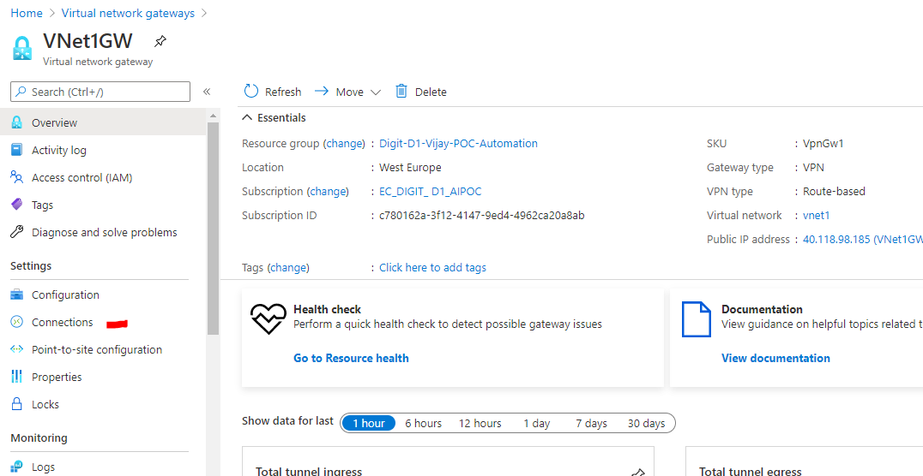

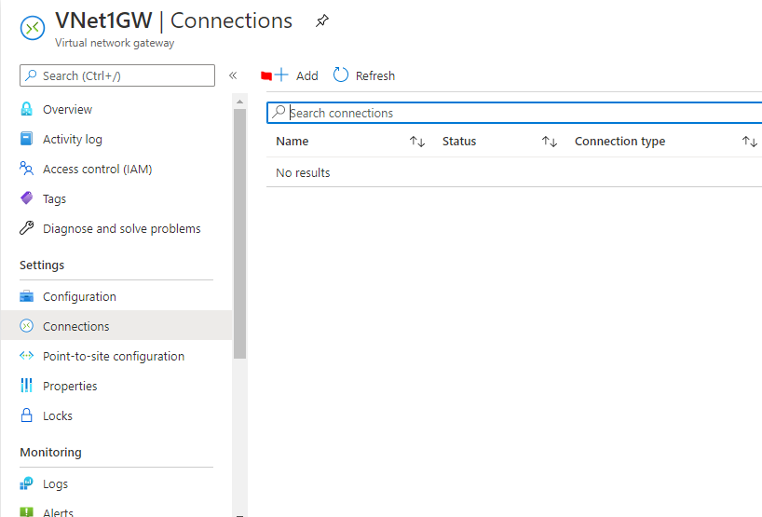

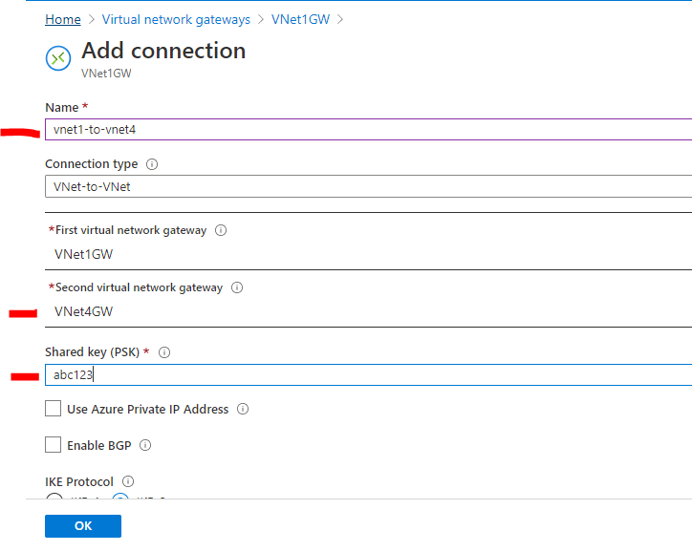

Now goto vnet gateway 4

Do the same vnet4 to vnet 1-🡪 secret name – abc123

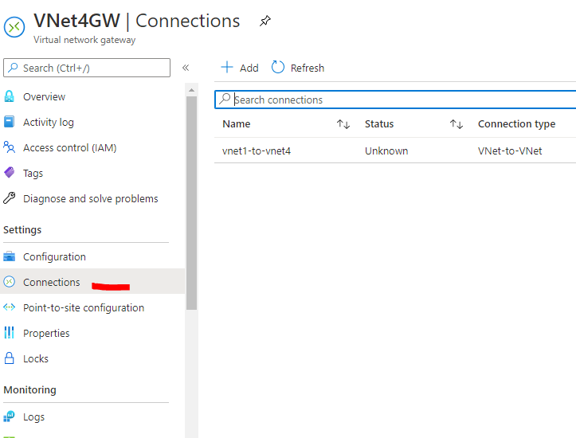

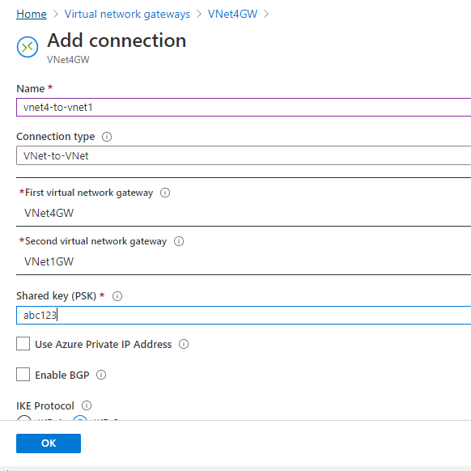

Now create one VM in Vnet1 and another VM in VNET4

Login in each machine and try to ping other machine.

VM in VNET1

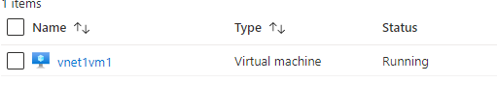

VM in VNET4

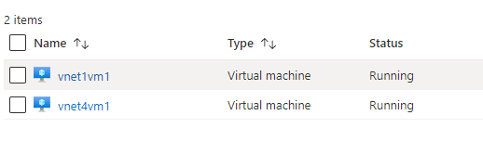

Go to each vm serial console option.if you get any warning then go to boot diagnostics…enable

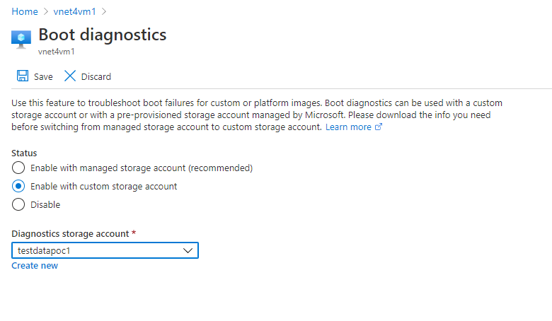

Now go to serial console and it will work.

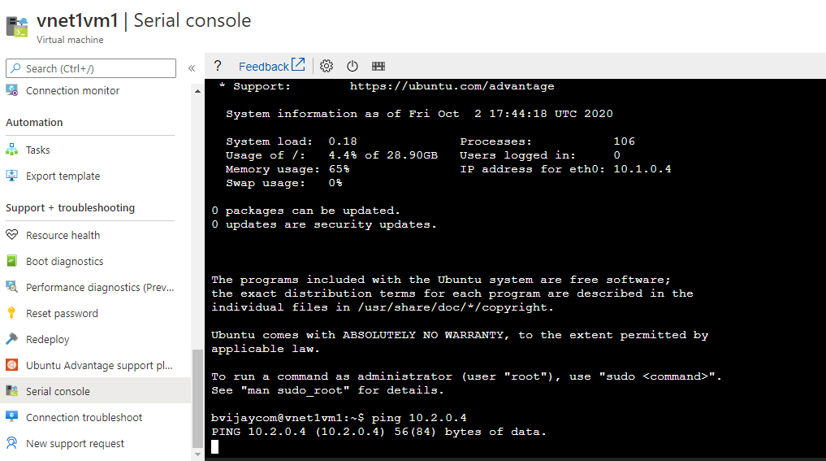

Now try from VNET4 VM 4 machine

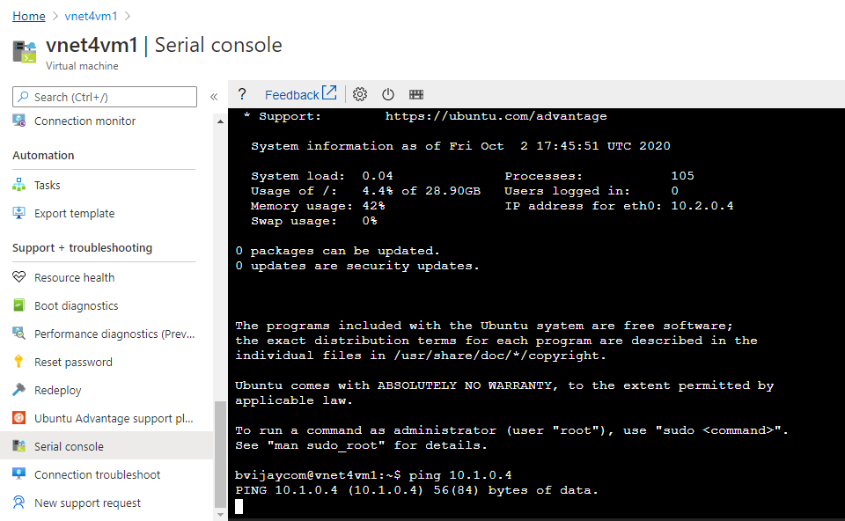

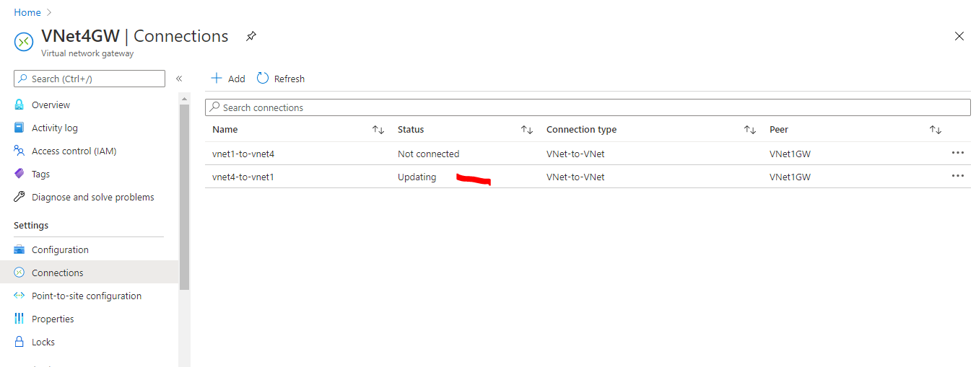

Now see from both machines

